Pray Boldly

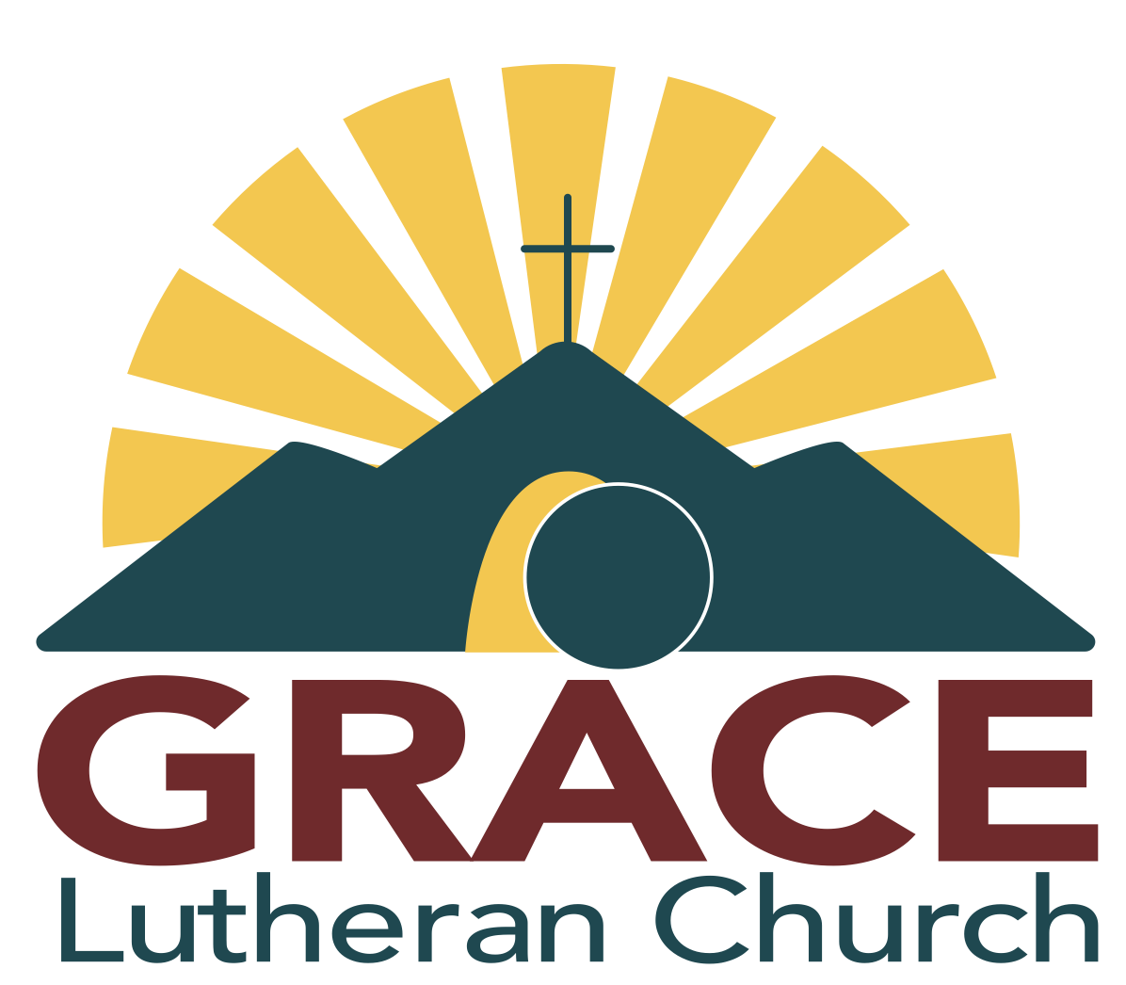
Tenth Sunday after Pentecost

August 17,
2025

Welcome, guests! We're delighted that you could join us. If you have any questions or would like more information about our church, any member of Grace would be more than happy to assist you. This folder includes all the details about our services, with the congregational responses indicated by indented, bold letters. Please take a moment to fill out the guest register at the church’s entrance; this will be used solely by the pastor and elder. Restrooms are located to the left as you exit the sanctuary. May the Lord bless this service as Christ comes to you!
The Theme for Today’s Readings: The believer prays boldly. The Prayer of the Day beautifully centers worship for this Sunday: God’s ears are open; let us then boldly ask for the blessings he promises.
Prayer for the Day: O Lord, your ears are always open to the prayers of your humble servants, who come to you in Jesus’ name. Teach us always to ask according to your will that we may never fail to obtain the blessings you have promised; through Jesus Christ, your Son, our Lord, who lives and reigns with you and the Holy Spirit, one God, now and forever. Amen.
Order for Today’s Service: Common Worship with Communion – CW, Pg. 15

Opening Hymn: #232
Lord of My Life, Whose Tender Care **Please Stand for The Last Verse**
In the name of the Father and of the Son (†) and of the Holy Spirit. 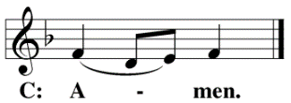
Confession of Sins
Beloved in the Lord: let us draw near with a true heart and confess our sins to God our Father, asking him in the name of our Lord Jesus Christ to grant us forgiveness.
Holy and merciful Father, I confess that I am by nature sinful and that I have disobeyed you in my thoughts, words, and actions. I have done what is evil and failed to do what is good. For this, I deserve your punishment both now and in eternity. But I am truly sorry for my sins, and trusting in my Savior Jesus Christ, I pray: Lord, have mercy on me, a sinner.
Lord, Have Mercy Kyrie
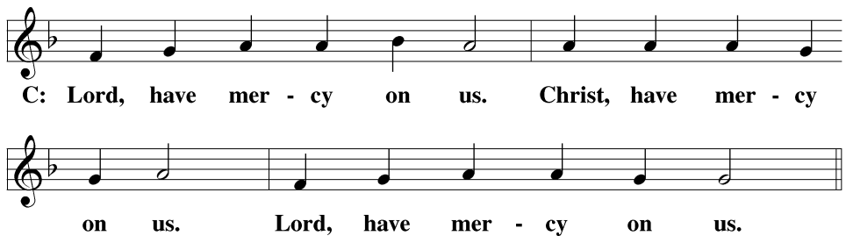
God, our heavenly Father, has been merciful to us and has given his only Son to be the atoning sacrifice for our sins. Therefore, as a called servant of Christ and by His authority, I forgive you all your sins in the name of the Father and of the Son (†) and of the Holy Spirit.
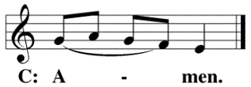
Prayer and Praise
In the peace of forgiveness, let us praise the Lord.
Glory Be to God Gloria in Excelsis
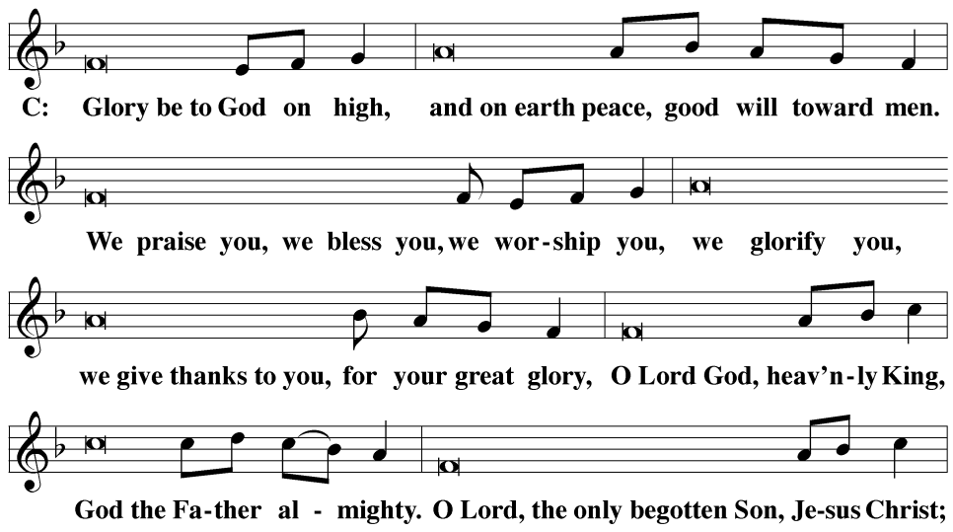
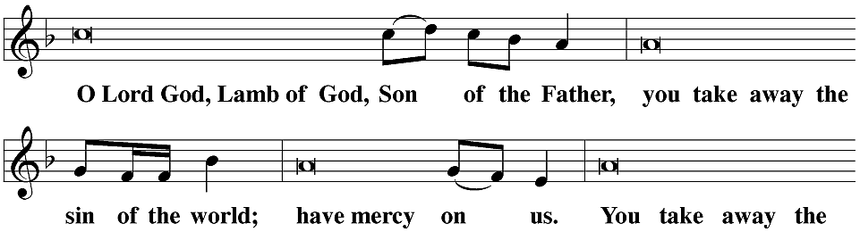
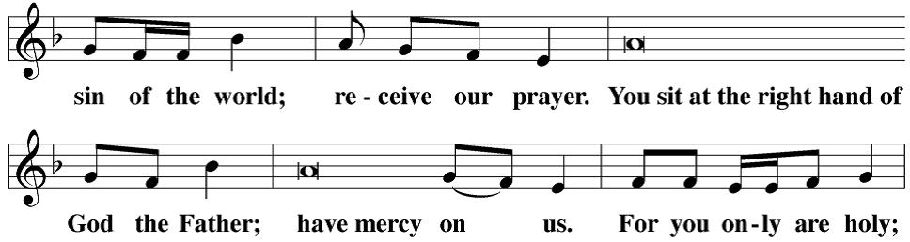
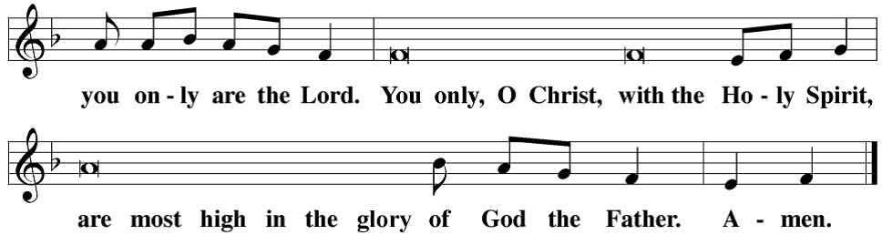
Prayer of the Day
The Lord be with you. 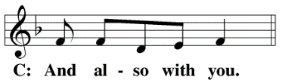
Let us pray.
O Lord, your ears are always open to the prayers of your humble servants, who come to you in Jesus’ name. Teach us always to ask according to your will that we may never fail to obtain the blessings you have promised; through Jesus Christ, your Son, our Lord, who lives and reigns with you and the Holy Spirit, one God, now and forever.
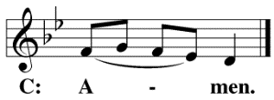
**Please Be Seated**
First Lesson: Genesis 18: 20 – 32
Abraham’s continued pressing of God for concessions would have seemed presumptuous to any earthly master. Yet Abraham was as bold as this when talking to God! On hearing of the Lord’s plans for wicked Sodom, Abraham shamelessly presses the Lord to live up to the meaning of his name. Our confidence is the same as we boldly come before our heavenly Father’s throne seeking his free and faithful grace.
So the Lord said, “Because the outcry against Sodom and Gomorrah is great, and because their sin is very flagrant, I will go down now and see if what they have done is as bad as the outcry that has come to me. If not, I will know.” The two men turned from there and went toward Sodom, but Abraham remained standing before the Lord. Abraham approached him and said, “Will you really sweep away the righteous along with the wicked? What if there are fifty righteous people in the city? Will you really sweep them away and not spare the place for the sake of the fifty righteous who are in it? You would never do such a thing, killing the righteous along with the wicked, treating the righteous the same as the wicked. You would never do such a thing. The Judge of all the earth should do right, shouldn’t he?”
The Lord said, “If I find fifty righteous people within the city of Sodom, then I will spare the entire place for their sake.” Abraham answered, “See now, I who am but dust and ashes have taken it on myself to speak to my Lord. What if there are five fewer than fifty righteous? Will you destroy the entire city if the number is five short?” He said, “I will not destroy it if I find forty-five there.”
He spoke to him yet again and said, “What if only forty are found there?” He said, “I will not do it for the sake of the forty.” He said, “Please, do not be angry, my Lord, but I will speak again. What if thirty are found there?” He said, “I will not do it if I find thirty there.” He said, “See now, I have taken it upon myself to speak to my Lord. What if there are twenty found there?”He said, “I will not destroy it for the sake of the twenty.” He said, “Please, do not be angry, my Lord, but I will speak just once more. What if ten are found there?”
He said, “I will not destroy it for the sake of the ten.”
Psalm of the Day: Psalm 6
Refrain
O LORD, do not rebuke me in your anger*
or discipline me in your wrath.
Be merciful to me, LORD, for I am faint;*
O LORD, heal me, for my soul is in anguish.
Turn, O LORD, and deliver me;*
save me because of your unfailing love.
Refrain
I am worn out from groaning.*
My eyes grow weak with sorrow.
Away from me, all you who do evil,*
for the LORD has heard my weeping.
The LORD has heard my cry for mercy;*
the LORD accepts my prayer.
Glory be to the Father and to the Son*
and to the Holy Spirit,
as it was in the beginning,*
is now, and will be forever. Amen.
Refrain
Second Lesson Colossians 2: 6 – 15
The letter to Colossians points out the reason we can be so bold in prayer. God has given us the fullness of Christ. In him we were circumcised, buried, and raised to life. Sins forgiven, we have been made children of God who have every right and encouragement to ask of God—as a child would ask his dear father.
Therefore, just as you received Christ Jesus as Lord, continue to walk in him, by being rooted and built up in him, and strengthened in the faith just as you were taught, while you overflow in faith with thanksgiving.
See to it that no one takes you captive through philosophy and empty deceit, which are in accord with human tradition, namely, the basic principles of the world, but not in accord with Christ. For all the fullness of God’s being dwells bodily in Christ. And you have been brought to fullness in him. Christ is the head over every ruler and authority. You were also circumcised in him, with a circumcision not done by human hands, in the putting off of the body of flesh, in the circumcision of Christ, when you were buried with Christ in baptism. And in baptism you were also raised with him through the faith worked by the God who raised Christ from the dead.
Even when you were dead in your trespasses and the uncircumcision of your flesh, God made you alive with Christ by forgiving us all our trespasses. God erased the record of our debt brought against us by his legal demands. This record stood against us, but he took it away by nailing it to the cross. After disarming the rulers and authorities, he made a public display of them by triumphing over them in Christ.
Verse of the Day
Alleluia. Lord, to whom shall we go? You have the words of eternal life. Alleluia. (John 6:68 cf. NIV)
**Please Stand**
Gospel Luke 11: 1 – 13
The disciples came to Jesus seeking guidance on how to pray. Jesus responds, coupling the spiritual-gift petitions of the Lord’s Prayer with examples of the boldness with which our Father invites us to ask, seek, and knock. Rooted in the Word, these requests come from hearts of faith that have been taught to seek not only what we need but even what we want.
After the announcement of the Gospel, the congregation sings:
On another occasion, Jesus was praying in a certain place. When he finished, one of his disciples said to him, “Lord, teach us to pray, just as John also taught his disciples.”
He said to them, “When you pray, say, ‘Our Father in heaven, hallowed be your name. Your kingdom come. Your will be done on earth as it is in heaven. Give us each day our daily bread. Forgive us our sins, as we also forgive everyone who sins against us. And lead us not into temptation, but deliver us from evil.’”
He said to them, “Suppose one of you has a friend, and you go to him at midnight and tell him, ‘Friend, lend me three loaves of bread, because a friend of mine who is on a journey has come to me, and I do not have anything to set before him.’ And the one inside replies, ‘Don’t bother me. The door is already locked, and my children and I are in bed. I can’t get up and give it to you.’ I tell you, even if he will not get up and give him anything because he is his friend, yet because of his bold persistence, he will get up and give him as much as he needs.
“I tell you, keep asking, and it will be given to you. Keep seeking, and you will find. Keep knocking, and it will be opened to you. For everyone who asks receives. The one who seeks finds. And to the one who knocks, it will be opened.
“What father among you, if your son asks for bread, would give him a stone? Or if he asks for a fish, would give him a snake instead of a fish? Or if he asks for an egg, would give him a scorpion? If you then, though you are evil, know how to give good gifts to your children, how much more will your heavenly Father give the Holy Spirit to those who ask him?”
After the Gospel, the congregation sings:
Nicene Creed
We believe in one God, the Father, the Almighty, maker of heaven and earth, of all that is, seen and unseen.
We believe in one Lord, Jesus Christ, the only Son of God, eternally begotten of the Father, God from God, Light from Light, true God from true God, begotten, not made, of one being with the Father. Through him, all things were made. For us and for our salvation, he came down from heaven, was incarnate of the Holy Spirit and the virgin Mary, and became fully human. For our sake, he was crucified under Pontius Pilate. He suffered death and was buried. On the third day, he rose again in accordance with the Scriptures. He ascended into heaven and is seated at the right hand of the Father. He will come again in glory to judge the living and the dead, and his kingdom will have no end.
We believe in the Holy Spirit, the Lord, the giver of life, who proceeds from the Father and the Son, who in unity with the Father and the Son is worshiped and glorified, who has spoken through the prophets. We believe in one holy Christian and apostolic Church. We acknowledge one baptism for the forgiveness of sins. We look for the resurrection of the dead and the life of the world to come. Amen.
**Please Be Seated**

Hymn Of The Day: #408
Christians, While on Earth Abiding

Sermon Text: Luke 11: 1 – 13
Sermon Theme: Pray with Confidence
**Please Stand**
Create in Me
**Please Be Seated**
Offering – In 2 Corinthians 9:7, Paul tells us: “Each one should give as he has determined in his heart, not reluctantly or under pressure, for God loves a cheerful giver.” This service is our gift to our guests; should you feel obliged to give, we thank you for your generosity.
**Please Stand**
Prayer for the Mission of the Church
Eternal God and Father, we give you thanks for the blessings we share as members of your holy Church, for your gracious Word and sacraments, for opportunities to worship and to grow in faith and knowledge, for occasions to serve and be served, for fellowship with believers in our congregation and in our synod.
Help us to rejoice in these blessings, dear Lord, and to use them faithfully.
Jesus Christ, Lord of the Church, you give grace to your people by calling us to be your witnesses in the world. Open our eyes to see the great and noble mission that lies before us. In the hurting eyes of the lonely, in the pained eyes of the sick, and in the searching eyes of the lost, help us to see your face, O Jesus, and to serve others as we would serve you.
Awaken us to the opportunities you give to proclaim your message of love to our family members and neighbors.
Holy Spirit, giver of life, through Word and sacrament, bestow on us the wisdom and power we need to clearly witness and to act boldly to those who live in Redmond and her surrounding cities. Help us to speak the truth in love, to give the reason for the hope we have, and to conduct ourselves with gentleness and respect.
Set our hearts on fire as we work and witness for Christ.
Hear us, Lord, as we pray for a family member, an acquaintance, a neighbor, or a friend who does not believe in you, or whose faith is weak or troubled.
Silent prayer.
Bless the Church with men and women who are willing to proclaim your Word in places where we cannot go. Keep them and their loved ones in your care, and let nothing hinder their work. By the power of the gospel, restore their spirits each day, so that they do not lose heart as they serve us and others.
Move us to support them with our sincere prayers and generous offerings.
Special Prayers and Intercessions
Wherever your Word is proclaimed, O Lord, grant it success. Let your kingdom come to us and others, so that we and many more might join the assembly of saints and angels to sing your praise forever.
Savior of all, hear our prayer and help us in our mission. Amen.
The Lord’s Prayer
Our Father, who art in heaven, hallowed be thy name, thy kingdom come, thy will be done on earth as it is in heaven. Give us this day our daily bread; and forgive us our trespasses, as we forgive those who trespass against us; and lead us not into temptation but deliver us from evil. For thine is the kingdom and the power and the glory forever and ever. Amen.
Distribution Hymn #409
Come, My Soul, with Every Care Vs 1 – 5

The Sacrament
**Please Stand**
The Lord be with you.
Lift up your hearts.
Let us give thanks to the Lord our God.
It is truly good and right that we should at all times and in all places give you thanks, O Lord, holy Father, almighty and everlasting God, through Jesus Christ our Lord, who promised that wherever two or three come together in his name, there he is with them to shepherd his flock till he comes again in glory. Therefore, with all the saints on earth and hosts in heaven, we praise your holy name and join their glorious song:
Holy, Holy, Holy Sanctus

Words of Institution
Our Lord Jesus Christ, on the night he was betrayed, took bread; and when he had given thanks, he broke it and gave it to his disciples, saying, “Take and eat; this is my (†) body, which is given for you. Do this in remembrance of me.”
Then he took the cup, gave thanks, and gave it to them, saying, “Drink from it, all of you; this is my (†) blood of the new covenant, which is poured out for you for the forgiveness of sins. Do this, whenever you drink it, in remembrance of me.”
The peace of the Lord be with you always.
O Christ, Lamb of God Agnus Dei
**Please Be Seated**
Distribution
Distribution – Please come forward at the direction of our usher. We do practice close communion according to Paul’s guidance in 1 Corinthians 11:27: “For if anyone eats and drinks in an unworthy manner because he does not recognize the Lord’s body, he eats and drinks judgment upon himself.” Therefore, if you are not a member of the ELS or WELS, please talk to Pastor Emmons before communing. Thank you for respecting our practices.
**Please Stand**
Song of Simeon Nunc Dimittis
O give thanks to the Lord, for he is good.
Closing Prayer
We give thanks, almighty God, that you have refreshed us with this holy supper. We pray that through it, you will strengthen our faith in you and increase our love for one another. We ask this in the name of Jesus Christ, our Lord, who lives and reigns with you and the Holy Spirit, one God, now and forever.
The Blessing
The Lord bless you and keep you.
The Lord, make his face shine on you and be gracious to you.
The Lord look on you with favor and (†) give you peace.
**Please Be Seated**

Closing Hymn: #372
I Lay My Sins on Jesus

What We Believe:
- Every word of the Bible is inspired, inerrant, and the only source of absolute truth.
- The Father, Son, and Holy Spirit form the triune God, the only true God.
- All humans are born dead in sin and deserve eternal condemnation.
- Jesus Christ is the true God; he was conceived in Mary’s womb by the Holy Spirit, adding a human nature to His divine nature.
- Only through His perfect work of redemption, which includes His perfect life and innocent death, are all sins for all people forgiven and given credit for His perfect life.
- Only those whom the Holy Spirit, through Word and Baptism, blesses with faith in Jesus’ redemptive work receive the benefit of it.
- The day is drawing near when Jesus will return to take all believers to heaven, condemn all unbelievers to eternal torment, and destroy this present world.
The Holy Bible, Evangelical Heritage Version® (EHV®) copyright © 2017 The Wartburg Project. All rights reserved. www.wartburgproject.org
Refrain Tune: Richard Proulx. © 1986 GIA Publications, Inc., Chicago, IL, www.giamusic.com. All rights reserved. Used by permission.
Lectionary listings from Christian Worship: A Lutheran Hymnal © 1993 Northwestern Publishing House. All rights reserved.

Announcements

Winkle: Pastor Emmons will be in Klamath Falls on Monday, August 18.
Installation in Sutherlin: Rev. Homer Mosley will be installed on September 6 at 1 pm, with Pastor Emmons participating in the service. Anyone interested in attending and wanting to ride with the pastor should contact him to make arrangements.
Afternoon with Luther: September 21 at 1 p.m. Grace will welcome Dwight Johnson from Colorado Springs as he performs a one-man play about the life of Martin Luther. This event is free and open to the public; there will be a door offering, and all proceeds will go to LMSG.
Giving Counselor: We thank Mr. Paul Manning, the Synod Giving Counselor, for meeting with us last week. If you would like to contact him about estate planning, church finances, or thank him for taking time away from his family to be with us, his email address is pmanning@blc.edu, and his phone number is 1-503-949-5324.
Sunday Morning Bible Study: The Holy Spirit and His role in our faith. Please join us at 9:00 a.m. Throughout August, we gather to hear how He calls us. We pray this Bible Study will be enlightening for you! Feel free to bring your questions; you can come and go as needed; reading is always optional, and questions are always welcome.
Midweek Bible Study: Join us at 6:30 p.m. at Greg and Penny Port’s house, 1923 NW Nickernut Ct, Redmond, to study the book of Joel. You can also join via Zoom. We will focus on the minor prophets of the Old Testament for the next twelve weeks. The Zoom link is provided, or you can email Pastor Emmons to get the link.
Zoom Meeting ID: 850 328 6057 Password: GraceOT
Visiting Our Neighbors: Pastor Emmons will be out on the streets Wednesday, Thursday, and Friday mornings from 10 a.m. to noon throughout July and August. Please consider joining him for some company.
Home Visits: Pastor Emmons will be making home visits. Please let him know if there are times when you're unavailable so he can plan your visit accordingly. This is a good opportunity to discuss any personal issues you may have or share ideas for our congregation.

Pastor: Roger Emmons Address: 945 SW Glacier Ave
Email: Roger.emmons@graceredmond.com Redmond, OR 97756
Web Site: https://graceredmond.com Mailing Address: PO Box 2396
Church Phone: 541-844-7100 Redmond, OR 97756
Cell Phone: 541-699-7643

