Jesus Ascended into Glory for Us

Sunday
after Ascension
May 17,
2026

Welcome, guests! We're delighted you could join us. If you have any questions or need more information about our church, any member of Grace will be happy to assist you. This folder contains all the details about our services, with congregational responses indicated by indentation and bold letters. Please take a moment to fill out the guest register at the church entrance; it will be used only by the pastor and elder. Restrooms are located to the left as you exit the sanctuary. May the Lord bless this service as Christ comes to you!
Theme for Today’s Readings: Christ rules all things for his Church. In the early 700s AD, there lived an English churchman known to history as the Venerable Bede. He was the great teacher of the Middle Ages, the man who divided history into AD and BC, the first great historian of the English language, and a devout man of God. On May 25, 735 AD, on the great Ascension Vigil, Bede finished his translation of the Gospel of St. John into Old English. Then, on that day of Ascension, he died. From his deathbed, the Teacher of the Middle Ages spoke the words that have become the Prayer of the Day on Ascension. This beautiful prayer sets the tone for the day, beginning with a note of triumph and ending with a supplication for the Spirit and his work.
Morning Prayer: Lord Jesus, King of glory, on Ascension you ascended far above the heavens and, at God’s right hand, you rule the nations. Leave us not alone, we pray, but grant us the Spirit of truth, so that at your command and by your power we may be your witnesses throughout the world; for you live and reign with the Father and the Holy Spirit, one God, now and forever. Amen.
Order for Today’s service: Common Worship with Communion– CW, p.15

Opening Hymn: #170
Draw Us to Thee **Please Stand for the Last Verse**
In the name of the Father and of the Son (†) and of the Holy Spirit. 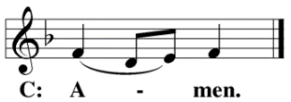
Confession of Sins
Beloved in the Lord: let us draw near with a true heart and confess our sins to God our Father, asking him in the name of our Lord Jesus Christ to grant us forgiveness.
Holy and merciful Father, I confess that I am by nature sinful and that I have disobeyed you in my thoughts, words, and actions. I have done what is evil and failed to do what is good. For this, I deserve your punishment both now and in eternity. But I am truly sorry for my sins, and trusting in my Savior Jesus Christ, I pray: Lord, have mercy on me, a sinner.
Lord, Have Mercy Kyrie
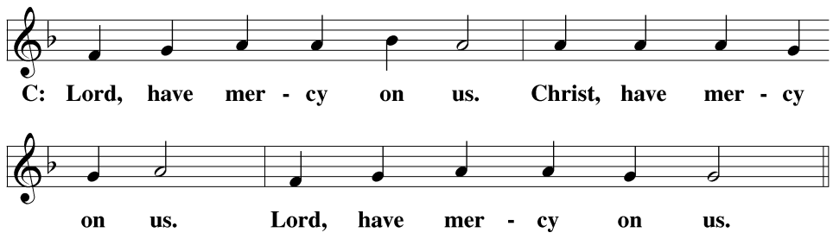
God, our heavenly Father, has been merciful to us and has given his only Son to be the atoning sacrifice for our sins. Therefore, as a called servant of Christ and by His authority, I forgive you all your sins in the name of the Father and of the Son (†) and of the Holy Spirit.
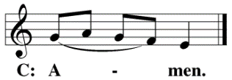
Prayer and Praise
In the peace of forgiveness, let us praise the Lord.
Glory Be to God Gloria in Excelsis
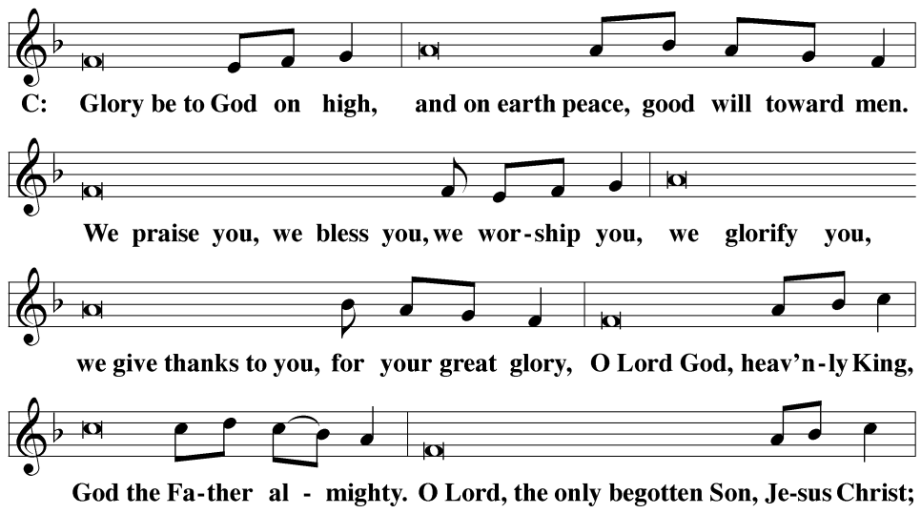
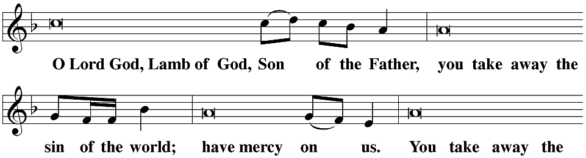
Prayer of the Day
The Lord be with you. 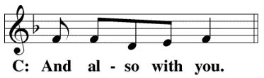
Let us pray.
Lord Jesus, King of glory, on Ascension you ascended far above the heavens and, at God’s right hand, you rule the nations. Leave us not alone, we pray, but grant us the Spirit of truth, so that at your command and by your power we may be your witnesses throughout the world; for you live and reign with the Father and the Holy Spirit, one God, now and forever.
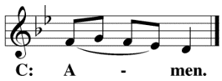
**Please Be Seated**
First Lesson: Acts 1:1 – 11
The weeks of Easter were filled with breathless joy in the presence of their living Savior. For forty days, the disciples listened to Christ speak about the kingdom of God. They had seen their Savior suffer; now they were ready to see him win. Christ’s answer gives direction to the Church of all time. They would receive power, but not for an earthly kingdom. Rather, they would receive the Spirit—power to be heralds of the impending kingdom of heaven.
I wrote my first book, Theophilus, about everything Jesus began doing and teaching until the day he was taken up, after he had given instructions through the Holy Spirit to the apostles he had chosen. After he had suffered, he presented himself alive to the apostles with many convincing proofs. He appeared to them over a period of forty days and told them things about the kingdom of God.
Once, when he was eating with them, he commanded them, “Do not depart from Jerusalem, but wait for what the Father promised, which you heard from me. For John baptized with water, but you will be baptized with the Holy Spirit not many days from now.” So when they were together with him, they asked, “Lord, is this the time when you are going to restore the kingdom to Israel?”
He said to them, “It is not for you to know the times or seasons that the Father has set by his own authority. But you will receive power when the Holy Spirit has come upon you, and you will be my witnesses in Jerusalem, in all Judea and Samaria, and to the ends of the earth.”
After he said these things, he was taken up while they were watching, and a cloud took him out of their sight. They were looking intently into the sky as he went away. Suddenly, two men in white clothes stood beside them. They said, “Men of Galilee, why are you standing here looking up into the sky? This same Jesus, who has been taken up from you into heaven, will come back in the same way you have seen him go into heaven.”
Psalm of the Day: Psalm 47
Refrain
Clap your hands, all you nations;*
shout to God with cries of joy.
How awesome is the LORD Most High,*
the great King over all the earth!
God reigns over the nations;*
God is seated on his holy throne.
Refrain
God has ascended amid shouts of joy,*
the LORD amid the sounding of trumpets.
Sing praises to God, sing praises;*
sing praises to our King, sing praises.
For God is the King of all the earth;*
sing to him a psalm of praise.
Glory be to the Father and to the Son*
and to the Holy Spirit,
as it was in the beginning,*
is now, and will be forever. Amen.
Refrain

Second Lesson Ephesians 1:16 – 23
The post-ascension disciples no longer had their teacher with them, walking the roads of Israel as before. We, end-time disciples, do not have Jesus’ visible presence with us either. Yet there is no sadness over the ascension, because the Church knows exactly where Christ is.
I never stop giving thanks for you, remembering you in my prayers. I keep praying that the God of our Lord Jesus Christ, the glorious Father, will give you the Spirit of wisdom and revelation in knowing Christ fully. I pray that the eyes of your heart may be enlightened, so that you may know the hope to which he has called you, just how rich his glorious inheritance among the saints is, and just how surpassingly great his power is for us who believe. It is as great as the working of his mighty strength, which God worked in Christ when he raised him from the dead and seated him at his right hand in the heavenly places, far above all rule, authority, power, and dominion, and above every name that is given, not only in this age but also in the one to come. God also placed all things under his feet and made him head over everything for the church. The church is his body, the fullness of him who fills everything in every way.
Verse of the Day
Alleluia. Alleluia. Christ is risen! He is risen indeed! Alleluia. Surely I will be with you always, to the very end of the age. Alleluia. (Matthew 28:20b)
**Please Stand**
Gospel Luke 24:44 – 53
Ascension marks the coronation of our Prophet-Priest as King. Today we witness his enthronement in glory and power to rule all things for the Church. Even at this late date, the disciples still failed to understand Jesus’ mission. So Christ opened the Scriptures to them to show once more that this was the Christ as prophesied.
After the announcement of the Gospel, the congregation sings:
He said to them, “These are my words that I spoke to you while I was still with you: Everything must be fulfilled that is written about me in the Law of Moses, the Prophets, and the Psalms.”
Then he opened their minds to understand the Scriptures. He said to them, “This is what is written and so it must be: The Christ will suffer and rise from the dead on the third day, and repentance and forgiveness of sins will be preached in his name to all nations, beginning from Jerusalem. You are witnesses of these things. Look, I am sending you what my Father promised. But stay in the city until you are clothed with power from on high.”
He led them out as far as the vicinity of Bethany. He lifted up his hands and blessed them. And while he was blessing them, he parted from them and was taken up into heaven. So they worshipped him and returned to Jerusalem with great joy. They were continually in the temple courts, praising and blessing God. Amen.
After the Gospel, the congregation sings:
Nicene Creed
We believe in one God, the Father, the Almighty, maker of heaven and earth, of all that is, seen and unseen.
We believe in one Lord, Jesus Christ, the only Son of God, eternally begotten of the Father, God from God, Light from Light, true God from true God, begotten, not made, of one being with the Father. Through him all things were made. For us and for our salvation, he came down from heaven, was incarnate of the Holy Spirit and the virgin Mary, and became fully human. For our sake, he was crucified under Pontius Pilate. He suffered death and was buried. On the third day, he rose again in accordance with the Scriptures. He ascended into heaven and is seated at the right hand of the Father. He will come again in glory to judge the living and the dead, and his kingdom will have no end.
We believe in the Holy Spirit, the Lord, the giver of life, who proceeds from the Father and the Son, who in unity with the Father and the Son is worshiped and glorified, who has spoken through the prophets. We believe in one holy Christian and apostolic Church. We acknowledge one baptism for the forgiveness of sins. We look for the resurrection of the dead and the life of the world to come. Amen.
**Please Be Seated**

Hymn of the Day: #171
A Hymn of Glory Let Us Sing
Sermon Text: Acts 1:1 – 11
Sermon Theme: Jesus’ Return Is Promised; He Will Return
Create in Me
**Please Be Seated**
Offering – Paul tells us in 2 Corinthians 9: 7: “Each one should give as he has determined in his heart, not reluctantly or under pressure, for God loves a cheerful giver.” This service is our gift to our guests; should you feel obliged to give, we thank you for your generosity.
Prayer of the Church for Ascension
O Lord Jesus Christ, exalted far above all principalities, powers, might, and dominion, at whose name every knee should bow, not only in this world but also in the world to come,
accept our praise and adoration.
We know that our praise cannot exalt You any higher than Your position at the right hand of God the Father,
yet we are bold enough to believe that You delight in the acclamation of Your children.
Accept our humble thanks for giving us the privilege of being part of Your body, the Church. For the many appearances You made after Your resurrection, proving to witnesses that:
You had risen from the dead, and we are grateful.
We also thank You for gathering so many of the faithful to witness Your ascension.
These witnesses to Your resurrection and ascension inspire us to follow You.
As the ascended Head of the Church, O Lord, You are aware of the many problems the Church faces today. We do not ask that our work be made easier,
but only for Your power to help us cope with the problems.
Help us be your hands,
doing deeds of kindness.
Help us to be Your feet,
running errands of mercy.
Help us to be Your mouth,
witnessing to our neighbors about Your love and salvation.
Special Prayers and Intercessions
Lord, in Your mercy,
hear our prayer.
Silent prayer.
When at last we have fulfilled Your purpose in our lives,
take us to Your Ascension throne, where we may share Your glory forevermore. Amen.
The Lord’s Prayer
Our Father, who art in heaven, hallowed be thy name, thy kingdom come, thy will be done on earth as it is in heaven. Give us this day our daily bread; and forgive us our trespasses, as we forgive those who trespass against us; and lead us not into temptation but deliver us from evil. For thine is the kingdom and the power and the glory forever and ever. Amen.
**Please Be Seated**
Distribution Hymn #351
Hail, O Once-Despised Jesus!
**Please Stand**
The Sacrament
The Lord be with you.
Lift up your hearts.
Let us give thanks to the Lord our God.
It is truly good and right that we should at all times and in all places give you thanks, O Lord, holy Father, almighty and everlasting God, through Jesus Christ, our Lord, and we praise you especially for the glorious resurrection of your Son, the true Passover Lamb, who by his sacrifice took away the sins of the world and by the resurrection restored everlasting life. Therefore, with all the saints on earth and hosts in heaven, we praise your holy name and join their glorious song:
Holy, Holy, Holy
Words of Institution
Our Lord Jesus Christ, on the night he was betrayed, took bread; and when he had given thanks, he broke it and gave it to his disciples, saying, “Take and eat; this is my (†) body, which is given for you. Do this in remembrance of me.”
Then he took the cup, gave thanks, and gave it to them, saying, “Drink from it, all of you; this is my (†) blood of the new covenant, which is poured out for you for the forgiveness of sins. Do this, whenever you drink it, in remembrance of me.”
The peace of the Lord be with you always.
O Christ, Lamb of God Agnus Dei
**Please Be Seated**
Distribution
Distribution – Please come forward at the direction of our usher. We do practice close communion according to Paul’s guidance in 1 Corinthians 11:27: “For if anyone eats and drinks in an unworthy manner because he does not recognize the Lord’s body, he eats and drinks judgment upon himself.” Therefore, if you are not a member of the ELS or WELS, please talk to Pastor Emmons before communing. Thank you for respecting our practices.
**Please Stand**
Song of Simeon Nunc Dimittis
O give thanks to the Lord, for he is good.
Closing Prayer
We give thanks, almighty God, that you have refreshed us with this holy supper. We pray that through it, you will strengthen our faith in you and increase our love for one another. We ask this in the name of Jesus Christ, our Lord, who lives and reigns with you and the Holy Spirit, one God, now and forever.
Blessing
The Lord bless you and keep you.
The Lord, make his face shine on you and be gracious to you.
The Lord look on you with favor and (†) give you peace.
**Please Be Seated**
Closing Hymn: #173
On Christ’s Ascension, I Now Build

What We Believe:
- Every word of the Bible is inspired, inerrant, and the only source of absolute truth.
- The Father, Son, and Holy Spirit form the triune God, the only true God.
- All humans are born dead in sin and deserve eternal condemnation.
- Jesus Christ is the true God; he was conceived in Mary’s womb by the Holy Spirit, assuming His human nature to His divine nature.
- Only through His perfect work of redemption, which includes His perfect life and innocent death, are all sins for all people forgiven and given credit for His perfect life.
- Only those whom the Holy Spirit, through Word and Baptism, blesses with faith in Jesus’ redemptive work, receive the benefit of it.
- The day is drawing near when Jesus will return, all believers will be with Him in heaven, all unbelievers will be condemned to eternal torment, and this present world will be destroyed.
The Holy Bible, Evangelical Heritage Version® (EHV®), © 2017 The Wartburg Project. All rights reserved. www.wartburgproject.org
Refrain Tune: Dale Wood. From Seasonal Psalms. © 1978 Augsburg Publishing House. All rights reserved. Used by permission of Augsburg Fortress.
Lectionary listings from Christian Worship: A Lutheran Hymnal © 1993 Northwestern Publishing House. All rights reserved.

Announcements

Annual Voters’ Meeting: Our church will hold the annual Voters’ Meeting—voting members include all our confirmed men over 18—will follow the service.
Area Pastor Meeting: pastors from the southern district 12 will meet in Redmond this Monday, May 18.
Bible Information Class: We have just begun a new class on Thursday evenings at 6 pm. Gene Baldwin is hosting it at his home. Please contact Pastor Emmons or Gene for directions. All our members are also welcome to attend; you can also tune in via Zoom using the link posted for the midweek Bible Study.
Sunday Morning Bible Study: Please consider our Sunday morning adult Bible Study as we study Paul’s letter to the church at Ephesus.
Midweek Bible Study: Our Tuesday evening Bible Study has resumed. We will meet at 6 pm at Carroll’s home, 3211 SW Umatilla Rd., or join us on Zoom. We will begin our study of the book of Isaiah.
Zoom Meeting ID: 850 328 6057 Password: GraceOT
Pastor Out of Town: Pastor and Tammi will be on vacation from May 31 to June 10. For emergencies, please contact Elder Gene Baldwin at 541-610-9978, as Pastor will be out of phone coverage while he is away.
Candy Jars: Please enjoy a jar of candy! You are welcome to return the jar with spare change, bills, or a check to raise funds for the ELS Women’s Missions Society District 12. The District 12 Women’s Group voted to designate the funds for the ELS Ukraine Special Projects (Foreign Missions) and the ELS Bethany Lutheran College Scholarships for Teacher Certification for 2026. Questions? Please talk with Penny Port and Mavis Vandelicht. Please return jars by May 31st. Checks should be written to Grace Lutheran Church. District 12 meets annually on the last weekend in September. The 2026 Rally is scheduled to be held in Klamath Falls, Oregon.

Pastor: Roger Emmons Address: 945 SW Glacier Ave
Email: Roger.emmons@graceredmond.com Redmond, OR 97756
Website: https://graceredmond.com Mailing Address: P.O Box 2396
Church Phone: 541-844-7100 Redmond, OR 97756
Cell Phone: 541-699-7643

